<https://www.youtube.com/watch?v=GILNR2ifxTc&t=18s>

Steps

1. **DOWNLOAD** **VMWware workstation pro**. Download from the following link (Follow the steps at the bottom of the webpage) <https://knowledge.broadcom.com/external/article/344595/downloading-vmware-workstation-pro.html>
2. INSTALL VMWare PRO
3. Install WINDOWs Server ISO from Microsoft Page
4. Start Adding VMs
   1. Go to file and choose new virtual machine
   2. Choose typical

* 1. 4.3. Choose I will install the operating system later

* 1. Choose window and 2019 or 2022 whichever ISO file you downloaded

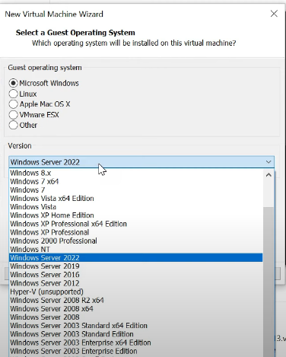

* 1. Choose directory to save the VM

* 1. Choose size e.g. 35gb or more if you have enough space

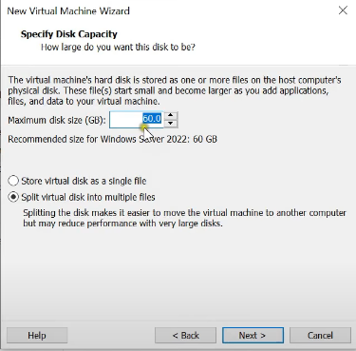

* 1. Expand custom hardware and choose ram size and on CD choose ISO image and close

* 1. Click finish. It is done here. Next is to Power ON the VM.
  2. Poweron Virtual machine and immediately press enter after CD/DVD is displayed

* 1. Follow the instructions to complete window server installation. Towards the end it asks for Admin account by default appears as “Administrator” and insert a Password that you won’t forget.

<https://www.youtube.com/watch?v=GILNR2ifxTc&t=18s>

domain controller

on domain controller set static ip

control panel – network and sharing center – Change adapter settings. New window pops up (Ethernet) right click and property. Choose IPV4 and assign IP and set preferred DNS of DC vm for non-DC vms.

Make the ip static and **add the DNS server’s IP in preferred dns server**.

While adding VMs to domain

Make sure internet and firewall are turned off.

With changes make sure VMs are restarted.

While building AG

Build the cluster before you enable alwayson feature in configuration manager. If you enabled it ahead, disable and reenable it after you build the failover cluster.

If you install SQL server with non-domain account like NT, you will likely see the secondary server not working in AG. So use AG account (administrator e.g.)

Make sure all TCP IP needed are enabled (1433,1434,5022 + UDP 3343) and TCP is enabled in SQL server configuration manager.

Servers have to built similar built like 2019 or 2022, mixing wont work for AG.